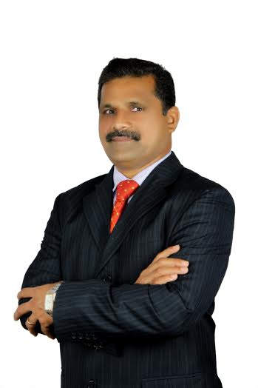**Holistic Approach**

“Nothing is worth it if you aren’t happy” Anonymous

Human beings are striving to achieve happiness. However, the term happiness is different from person to person. Your term of happiness may not be the same for me and so on.

After going through the wonderful life and learning the life learning lessons. I realized one should have a holistic approach while leading the life.

Therefore, Every individual should have a Vision and Mission to lead a fantastic life.

I wrote my Vision and Mission some years ago ***“Attain utmost peaceful life through Mind, body, spirit, relationship and financial freedom”.***

Writing the Vision and Mission is very simple but to follow it and to achieve it very challenging. When I started following the holistic approach, things started attracting towards me.

**Positive Mind:** Today’s world the main route cause of chaos is because of unclean thought. We have been reading and hearing every now and then the negative news. I have developed a skill of converting the negative into positive things. This skill can be learned and can be practiced.

Someone rightly said, “***If you sow thoughts you will reap an Action; If you sow an action you will reap habit; If you sow habit you will reap Character; If you sow character you will reap destiny”***. If your thoughts are positive you will have positive destiny and vice versa.

**Healthy Body:** With the advancement of science and Technology, there is a need to do more in less time. This builds stress to most of us. In that process our food habits changes, time of consuming the foods changes and this leads to many stress related deceases. Can we have a solution to this.

10 minutes of simple exercise will help you to rejuvenate your body. If you are lucky and have more time go for gym or Yoga for one hour, which will help you to come out these stress related deceases.

**Spiritual:**  Spiritual does not mean that one must be religious. Simple gratitude to the creator for giving us the nature free of cost would enough. One simple thanks when you wake up in the morning is good enough to start the day. Reciting few lines from the holy book of your own religion would expand your wisdom and gives you mental peace.

**Relationship:** Maintaining the relationship one of the critical element of achieving peace. Strong fundamental principles are to be followed while maintaining the relationship. The relationship may be between spouses, parents and children, Siblings and Relatives

Relationship can be extended to social and colleagues and friends. Many great things can be achieved through relationship. If someone does not believe in this simple principle, better to ignore such people and do not connect with those who do not understand it, even though they are your own family members

**Financial Freedom**: You might have observed and experienced that financial freedom is one of the greatest booster for the peaceful life. Financial freedom does not mean that one should have millions and millions of dollars into their bank account. The real meaning is that one should be satisfied with to lead a life without becoming a burden to others. One must work towards the financial freedom by setting a financial goal and to build the required funds to take care of their own basic needs of food, clothing, shelter, medical, education and other required needs.

Is it possible to achieve the holistic approach? “What the mind of man conceives and believe, it can achieve” Napoleon Hill.

Finally, one must believe in himself; Believe in yourself and have faith. You will have great things in life

Wish you all the Division F Toastmasters a wonderful year 2017-18 and wish you great years ahead.

**Wilson Lewis, DTM**

**Division F Director 2017-18**

Toastmasters International

Where Leaders Are Made

+971 50 420 3278

+971 55 637 0657

Email: Wilson.lewis35@gmail.com



